**Generating a Schedule**

A student can generate a schedule based on preferences. To do so, students need to go to the ‘Schedule Planner’tab from the home page once they have logged in (see Figure 1). Once the tab is selected, a set of preferences should be displayed (see Figure 2). Those preferences include the starting and ending time that the student would prefer to have for each week day. Students can choose to apply the preference filters for the days desired by selecting the checkboxes corresponding to the day (see Figure 3). Students can then select the times at which they wish to start and end their courses by scrolling down and choosing the offered times from the drop-down menus (see Figure 4). Once the preferences are set, the year(s) to be displayed can be chosen by click the appropriate checkboxes (see Figure 5). The next step is then to generate the schedule by clicking the ‘Generate Schedule’button (see Figure 6). A set of tabs, each representing an academic year, should be displayed on the bottom of the page. Each tab is divided into semesters. Every semester division contains a list of proposed lectures, tutorials and laboratories for all courses in the sequence that correspond to the time blocks selected (see Figure 7). All there is left to do is to choose the laboratory and tutorial times for each of the courses by selecting the checkbox corresponding to the desired sections (see Figure 8). Once those sections are chosen, students need to click the ‘Validate Schedule’button to ensure that the times are consistent and that no overlapping occurs (see Figure 9).

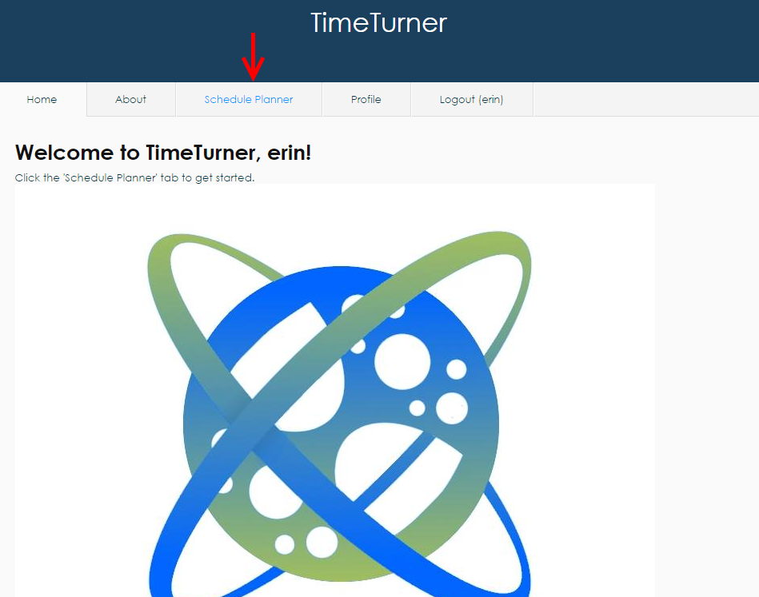

*Figure 1 Accessibility to the ‘Schedule Planner’ tab from the home page.*

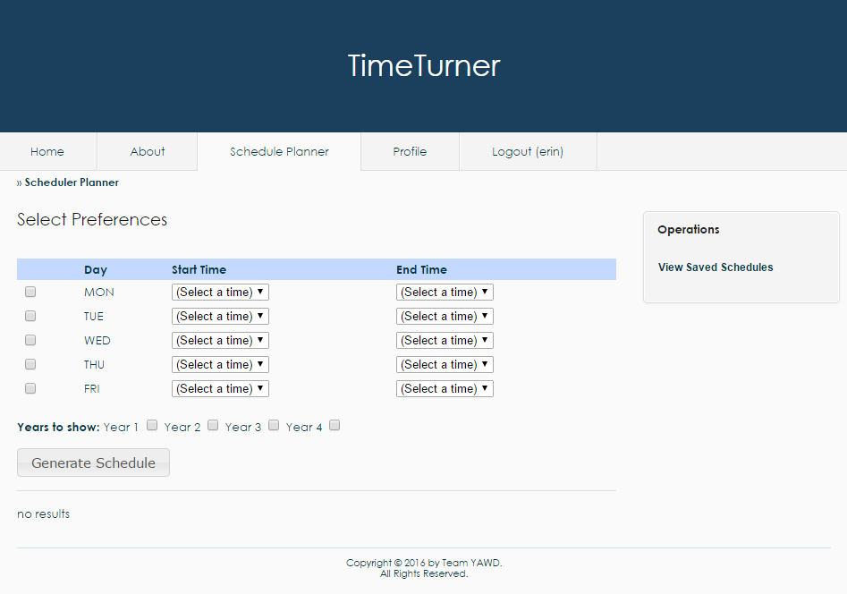

*Figure 2 Set of preferences displayed on the ‘Schedule Planner’ tab.*

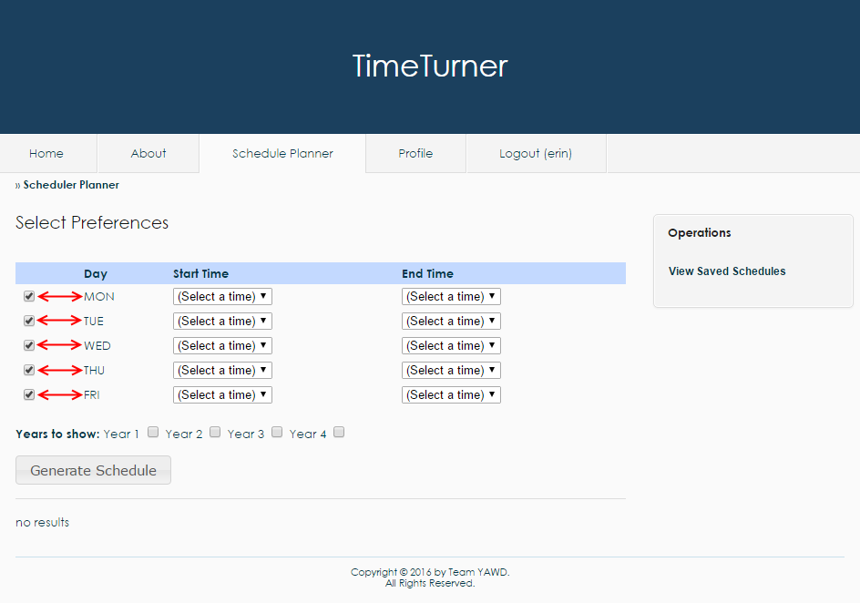

*Figure 3 Checkboxes corresponding to the day to be filtered.*

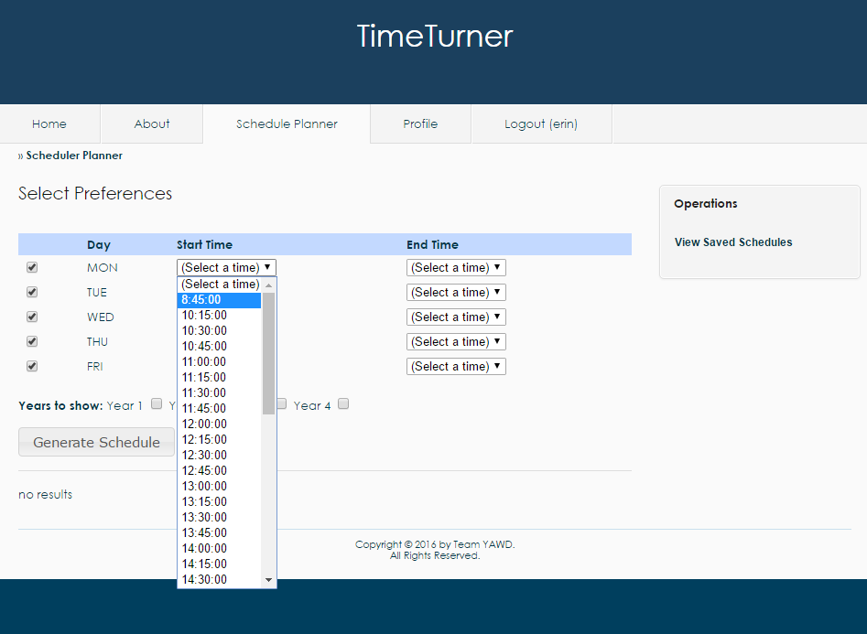

*Figure 4 Drop-down menu to select time preferences.*

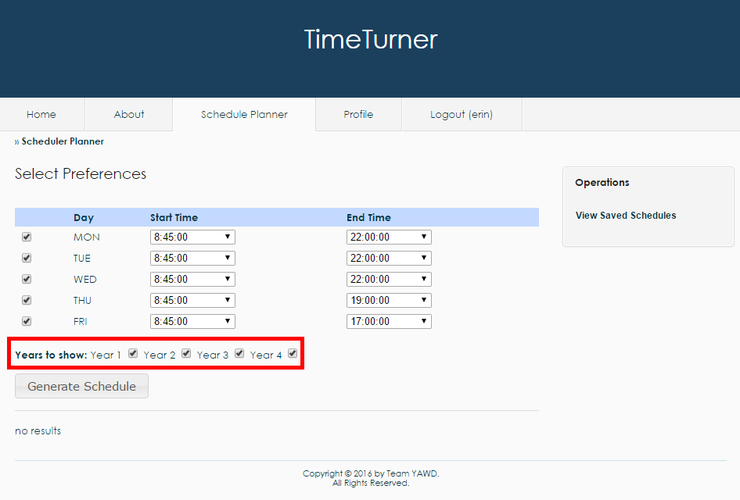

*Figure 5 Academic years to be displayed according to the set preferences.*

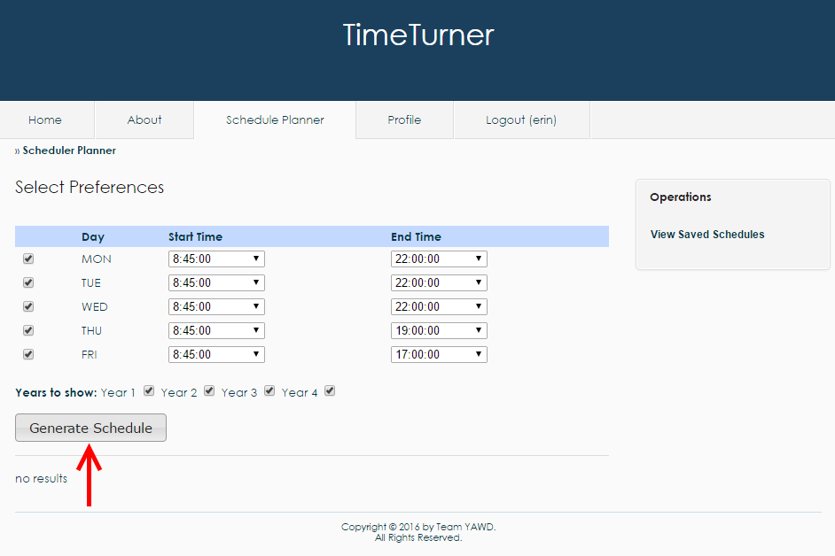

*Figure 6 The ‘Generate Schedule’ button to click when all preferences and years are set.*

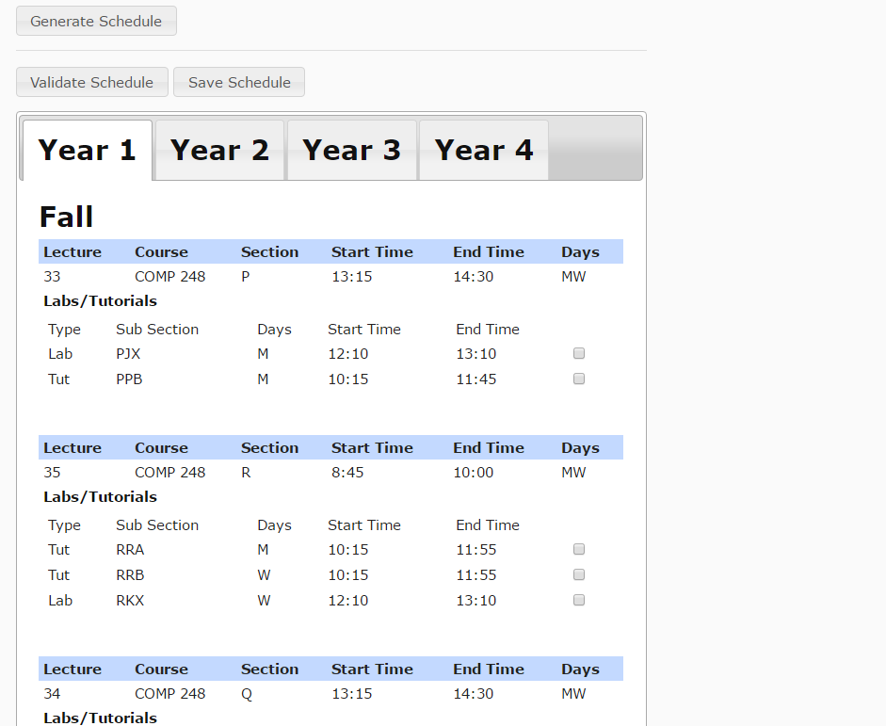

*Figure 7 Tabs representing each academic year selected with courses for each semester.*

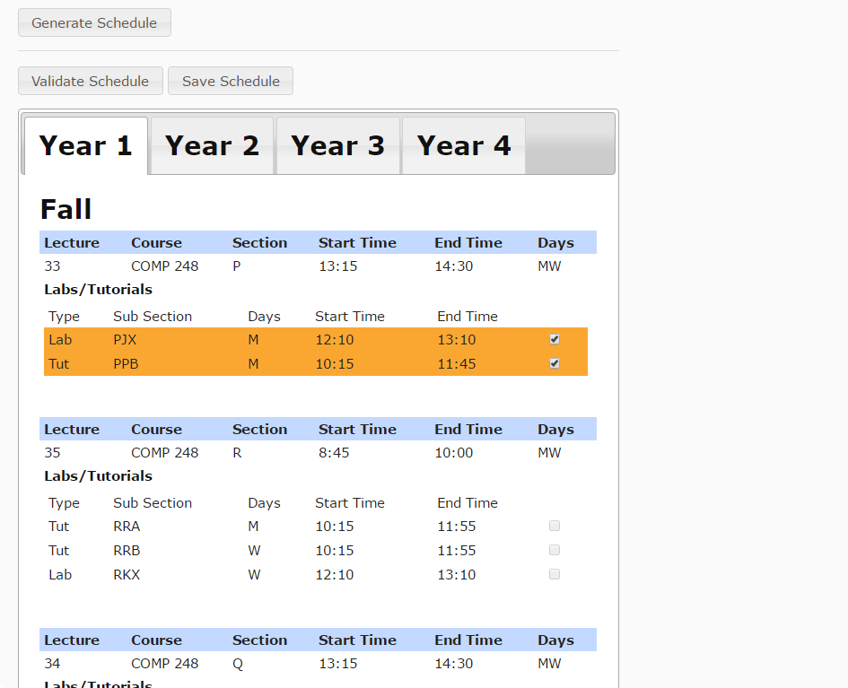

*Figure 8 Selection of the laboratory and tutorial sections. Notice that the checkboxes for tutorials and laboratories of other lecture sections of the same course have been disabled when one lecture section has been selected.*

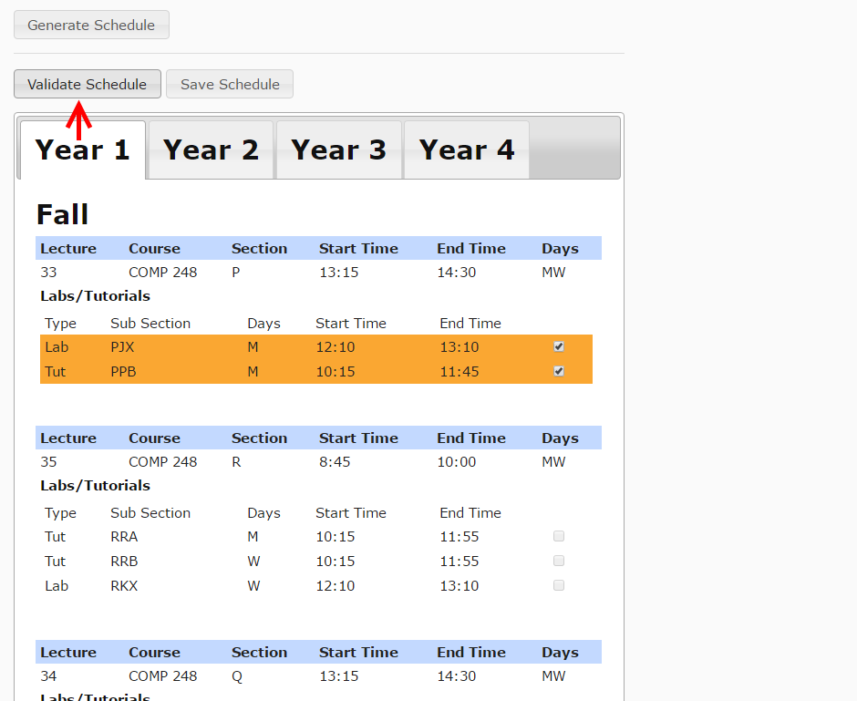

*Figure 9 Validation of the schedule once tutorial and laboratory sections have been chosen for all courses in all academic year through the ‘Validate Schedule’ button.*